Lab1: Docker basics

First we need to install Docker but I already have it installed when we were installing WSL. We can write the command: *apt install docker.io* to install it if we don’t have it in some other distribution

Next to see installed version and list of available commands we use these commands:

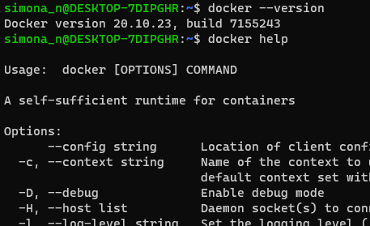

With the command docker info we can see the information of number of containers and images and we can see that the swarm is inactive

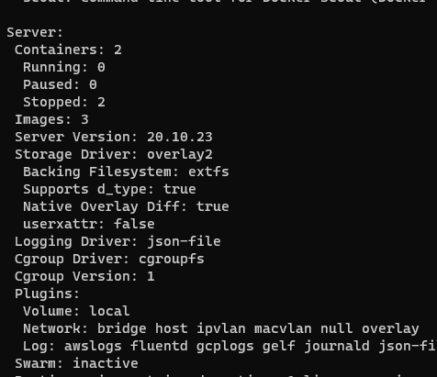

Lab2: Creating images

In this lab a folder is created with a script inside:

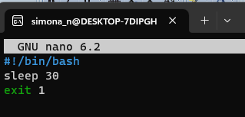

Then a Dockerfile is created also with nano editor:

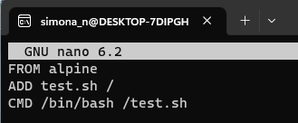

We build and run with the following commands: docker build –t my-image1 ./  
 docker run - -name my-test1 my-image1

Then we change the Dockerfile : 